“Read Me” File

- The Public Access Dump file accompanying this Read Me file is the public portion of the criminal history records maintained by the Minnesota Department of Public Safety, Bureau of Criminal Apprehension (BCA). It is up to the purchaser to provide the appropriate software to store, retrieve, and format this data based on their requirements. The BCA will NOT provide software or support for software to perform these functions.

- A new field, called “Statement of Disagreement” (SOD) is being added to the Public Data file which WILL impact the format of the data. If an individual has a disagreement with information maintained in the Computerized Criminal History system, they have a right to have their disagreement reported when their data is released. A SOD may be attached to Personal Data, Conviction Header, Conviction Data, or Confinement Data. The recommended format for this data is documented below:
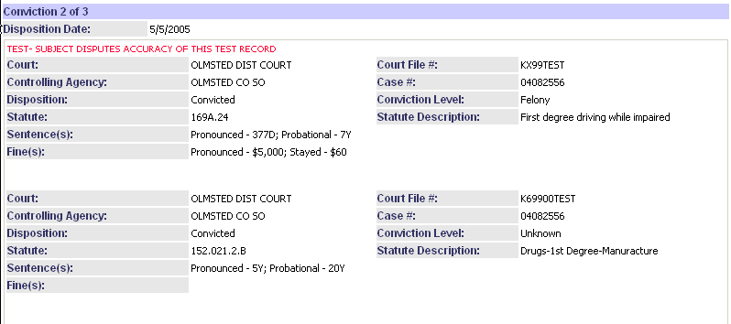

- CRITICAL CAVEAT: The following caveat must be included in any report released that has an “X” in the Question Identity Flag field of the Type 2 record:

CAUTION: An individual with this name has submitted fingerprints that indicate that he or she is NOT the subject of this record. The Minnesota Bureau of Criminal Apprehension has issued a letter to this individual, confirming that he or she is NOT the subject of this record. Fingerprint verification is the only way to confirm that an individual is or is not the subject of a record.

The following is an example of the implementation of the caveat where the QUESTION_IDENTITY_FLAG field was marked with an “X” for the Aliases EILEEN GRUET and MARY ELLEN SWARD:

NAME: Gray, Martha
Birth Date: 12/12/1954

SEX: F RACE: White

REPORTED ALIAS NAMES:

GORBER, ANETTE ****GRUET, EILEEN
GORBELLE, ANNETE THOMPSON, EMMA
****SWARD, MARY ELLEN FORRESTER, MARTHA
STEWART, MARY GRAY, MARTHA

****CAUTION: An individual with this name has submitted fingerprints that indicate that he or she is NOT the subject of this record. The Minnesota Bureau of Criminal Apprehension has issued a letter to this individual, confirming he or she is NOT the subject of this record. Fingerprint verification is the only way to confirm that an individual is or is not the subject of a record.

REPORTED DATES OF BIRTH:
09/28/1956 12/12/1954 10/04/1955

- It is important that you and your clients understand that criminal offenders frequently use aliases, including the names of other individuals. You and your clients should not assume search results correspond to the subject of their inquiry, and should use EXTREME CAUTION in making employment, housing and other decisions based upon this information. Fingerprint verification is the only way of confirming a subject's identity. Subjects should be afforded the opportunity to challenge correctness, accuracy and/or completeness of a record before being denied employment, housing, license, certification or privilege of any nature.

- The file provided to you includes a table of Reported Names. includes a table with the “primary” name and a table of “other names used”. While the BCA cannot determine the true name of an individual, the presence of alias names is an indicator that the subject may have used the identity of others.

- It is your responsibility to assure proper use of this data in accordance with applicable state and federal law. Please be advised that your improper use, retention or dissemination of this data may result in liability for you and/or your company/entity. Such liability may include, specifically but not exclusively, violations of the Fair Credit Reporting Act, 15 U.S.C. §§ 1681-81t, as well as civil lawsuits under state or federal law.

- The criminal history files at the BCA are continually updated adding new data, modifying data, and removing data when so ordered by the courts. In addition, because state law (MSS 13.87, subd. 2) states that the data are only public for 15 years following discharge from the sentence imposed, some of the data included herein will revert to private status and should not be used.

